*Florida International University*

*School of Computing and Information Sciences*

Software Engineering Focus

Feature Document

User Story ID #139

**Name:** Edit Fellowship

**Team Member(s):** Winicius Siqueira, Alfredo Morales

**Project:** Fellowship Management 1.0

**Product Owner(s)**: Robert Zurita

**Mentor(s)**: Mohsen Taheri

**Instructor**: Masoud Sadjadi

**User Story Name: Edit Fellowship**

* As an Admin User I would like to edit a fellowship so that the website reflects the correct information.

Acceptance Criteria

* An Admin User can edit a fellowship. The updated information for the fellowship will appear in the main page of the site.

**Use Case**

* Name: Edit Fellowship
* Actor: Admin User
* Preconditions: The Admin User has logged in, and from the following URL <http://localhost/fellowship/app/> the Admin User clicked on “Edit”.
* Description <Flow of events>: The Admin User fills out the form completely and clicks submit. If no fields are empty, and the Admin User clicks “Update Fellowship”, then the updated fellowship can be viewed in the home page. If a field is empty, then the user is sent back to the form to fill the empty field.

**Use Case Diagram <**you can use draw.io**>**

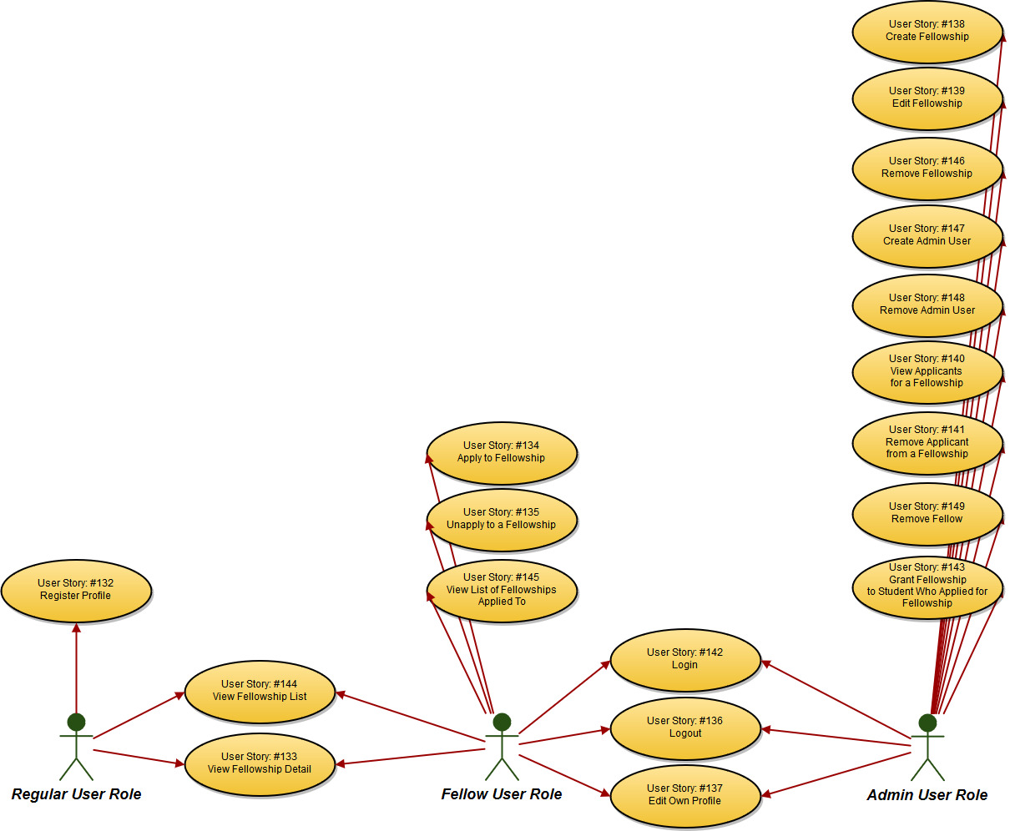

**Sequence Diagram**

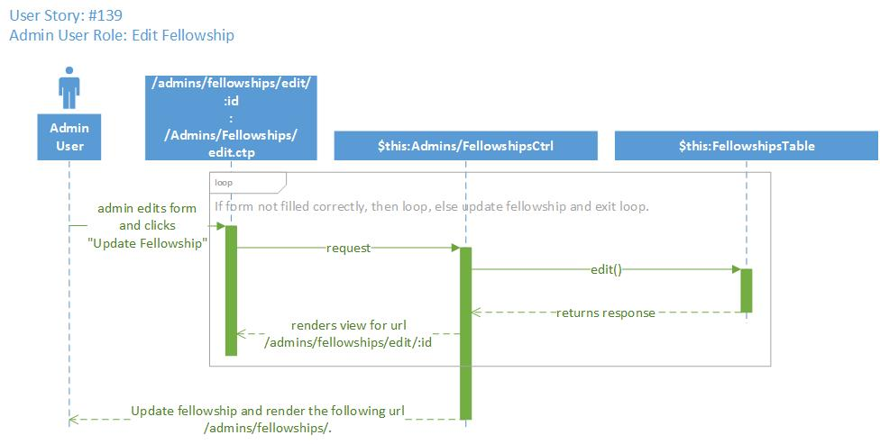

**Class Diagram**

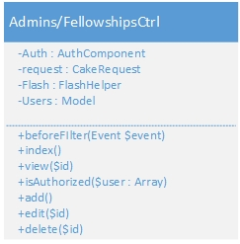

**Unit Test**

* Test case ID: testEditFellowshipPageLoadID139
* Description/Summary of Test: This test case checks that the following URL loads properly:

/admins/fellowships/edit/5

* Pre-condition: The session variable contains id=1 and username=’w’.
* Expected Results: The following page loads properly: /admins/fellowships/edit/5 and it contains the string “Update Fellowship”.
* Actual Result: The page does not load properly.
* Status (Fail/Pass): Fail

**Integration Test**

**Visual User Guide** <like one or two screenshots of the feature. For the hardware project, a photo of device is required>

